**Summary of optimizing promotion**

Supermarkets normally use promotion in order to reduce overstocked items.

Vegetables are very perishable items that their shelf life is relatively short compared to snacks or meats. Therefore, it is important to optimize the promotion strategy of vegetables.

**Promotion**

1. when to apply : Vegetables are overstocked than usual or the time left before expiration date is short.
2. condition : do not discount it when its substitute is also on discount.

ex) avoid discounting bio cucumber and cucumber at the same time.

1. objective : Optimizing profit while reducing overstocked vegetables
2. what to optimize : duration(from 1day to 7day) and discount amount(from 10% to 50%)
3. No seasonality & no trend : do not need to consider in the model
4. no post-promotion dip effect in demand

People tend to buy more than they need when items are on discount and store them at their home. So today's demand can be decreased if there was promotion yesterday. We could find this effect in snacks since people can easily store, but could not find in vegetables due to their short shelf life.

**BACKGROUND**

If there are n number of stocks, we have two scenarios.

(denote m as the left days before the expiration date)

First scenario : Let n be sold before m or exactly during m

Second scenario : Let only part of n be sold during m

(so there are wasted vegetable -> cost occurs)

If we vary the duration of the promotion and discount amount, we encompass both scenarios.

**model**

1. Use a regression model to predict quantity during discount/no discount.
2. Create the profit function using margin(p_sell - p_buy) and the cost

The cost occurs only If quantity <= stocks.

1. Parameters to determine the profit are n,m,D,d

n : the number of stocks,

m : days left before expiration date

D : duration of promotion

d : discount amount(unit : %)

1. Using the profit function, get optimized duration and discount amount using stochastic simulation.
2. Duration of the promotion and discount amount are constrained.

D : a positive integer from 1 to 7.

d : one of these(10%, 20%, 30%,40%,50%)

profit(n,m,D,d) = $\sum_{t=1}^{D}{}Q_{1_{t}}(P_{discount}-P_{purchase})+\sum_{t=D+1}^{m}{}Q_{2_{t}}(P_{sale}-P_{purchase})-cost$

$$Q_{1_{t}}(quantity during discount at time t) = a*C_{t} +b*{P_{discount}}_{}+intercept$$

$$Q_{2_{t}}(quantity without discount at time t) = a*C_{t} +b*{P_{sale}}_{}+intercept$$

where

$C_{t }(The number of customers at time t)$ ~ N(57,8.63)

$$P_{discount}=P_{sale}(1-0.01*d)$$

**Objective function**

$$argmax_{D, d} profit(n,m,D,d)$$

**subject to**

D $∈\{1,2,3,4,5,6,7\}$

d $∈\{10,20,30,40,50\}$

If n $≤{\sum_{t=1}^{D}{}Q}_{1_{t}}$, ${ \sum_{t=1}^{D}{}Q}_{1_{t}}=n and {\sum_{t=D+1}^{m}{}Q}_{2_{t}}=0$

(In case when all of stocks are sold before the expiration date)

if n $≥{\sum_{t=1}^{D}{}Q}_{1_{t}}$ and n $≤{\sum_{t=1}^{D}{}Q}_{1_{t}}+{\sum_{t=D+1}^{m}{}Q}_{2_{t}}$, ${\sum_{t=D+1}^{m}{}Q}_{2_{t}}$ = n - ${\sum_{t=1}^{D}{}Q}_{1_{t}}$

(in case when all of stocks are sold during no promotion days before the expiration date)

if n $≤{\sum_{t=1}^{D}{}Q}_{1_{t}}$ + ${\sum_{t=D+1}^{m}{}Q}_{2_{t}}$, cost = 0

otherwise, cost = (n- ${\sum_{t=1}^{D}{}Q}_{1_{t}}$- ${\sum_{t=D+1}^{m}{}Q}_{2_{t}}$) x ($P_{purchase}$)

(Note : C_t is normally distributed according to the QQ-plot)

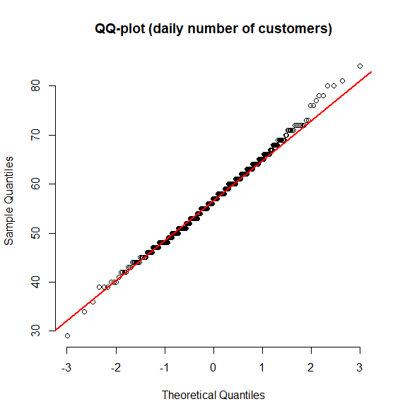

**result**

- courgette(zucchini) case -

when n(stocks)=100 and m(days left before the expiration date)=10,

What is the optimal discount amount and duration to maximize the profit?

We have many constraints and the customer number is a stochastic parameter.

So hard to calculate mathematically.

Thus, use the stochastic simulation!

The optimized duration is 7days and the discount amount is 10%.

Even though two items are not sold before the expiration date and the cost occurs around 1.04euro), 10% gives a good margin, so this maximizes the profit.

* **Visualization**

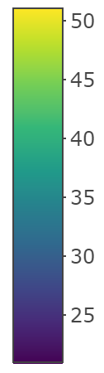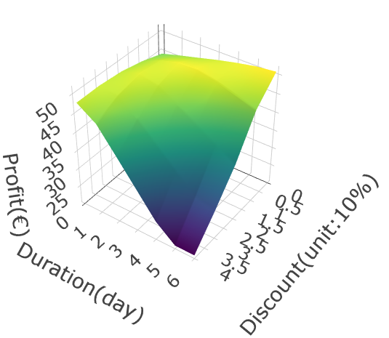

3D view : Profit tends to be increased as the discount is smaller and the duration is longer.

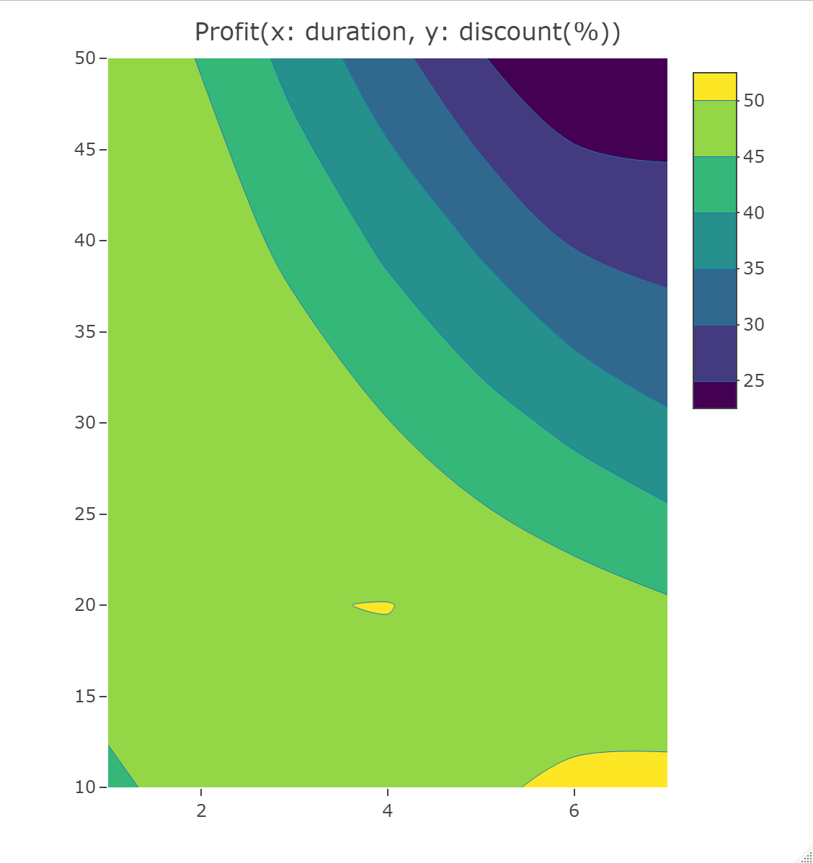

2D view : Yellow areas indicate the maximum profit.